REAL-TIME FACIAL EMOTION RECOGNITION WITH SELF SUPERVISED PERFORMANCE



UNIVERSITY OF ENGINEERING & MANAGEMENT, JAIPUR

Real-Time Facial Emotion Recognition with Self Supervised Performance
Submitted in the partial fulfilment of the degree of
BACHELOR OF TECHNOLOGY
In
COMPUTER SCIENCE & ENGINEERING
Under
UNIVERSITY OF ENGINEERING & MANAGEMENT, JAIPUR
BY
SANJANA SHAH
University Roll no: 12024002001094
University Registration no: 204202400200099
UNDER THE GUIDANCE OF
DR. RAHUL KUMAR GARG
COMPUTER SCIENCE & ENGINEERING



UNIVERSITY OF ENGINEERING & MANAGEMENT, JAIPUR

APPROVAL CERTIFICATE
This is to certify that the project report entitled “Real-Time Facial Emotion Recognition with Self Supervised Performance Analytics” submitted Sanjana Shah (12024002001094) in partial fulfilment of the requirements of the degree of Bachelor of Technology in Computer Science & Engineering from University of Engineering and Management, Jaipur was carried out in a systematic and procedural manner to the best of our knowledge. It is a Bonafide work of the candidate and was carried out under our supervision and guidance during the academic session of 2024-2028.

_________________________
Dr. Rahul Kumar Garg
Project Guide, Professor (CSE)
UEM, JAIPUR

_______________________
Prof. Dr. G Uma Devi
Associate Dean of Engineering &
Head of the Department (CSE)
UEM, JAIPUR

ACKNOWLEDGEMENT
The endless thanks goes to Lord Almighty for all the blessings he has showered onto us, which has enabled us to write this last note in our research work. During the period of our research, as in the rest of our life, We have been blessed by Almighty with some extraordinary people who have spun a web of support around us. Words can never be enough in expressing how grateful we are to those incredible people in our life who made this thesis possible. We would like an attempt to thank them for making our time during our research in the Institute a period we will treasure. We are deeply indebted to our research supervisor, Dr. Rahul Kumar Garg us such an interesting thesis topic. Each meeting with him added in valuable aspects to the implementation and broadened our perspective. He has guided us with his invaluable suggestions, lightened up the way in our darkest times and encouraged us a lot in the academic life.

Sanjana Shah (12024002001094)

ABSTRACT
Detecting emotions from a live webcam feed is a problem that seems easy until you try to do it. The issue is that you do not have any answers or labels you just have a camera and a person face. This project creates a system that detects emotions in time using a webcam. It uses Python and OpenCV and the DeepFace library. The system puts faces from the webcam into five emotion groups: Happy, Sad, Angry, Surprise and Neutral. It uses a 70 percent confidence level to decide if a detection is reliable or not. This helps to evaluate the emotion detection system without needing any data. The results are shown on a custom screen with confidence bars, a scrolling emotion timeline and a real-time accuracy counter. When the session ends the system automatically generates five charts: a grouped metrics bar chart, a pseudo-confusion matrix, a violin distribution plot, an emotion timeline and a Precision-Recall radar chart. The emotion detection system worked with a F1-Score of 0.59. The Happy emotion and the Surprise emotion did well with scores of 0.94 and 0.88. The Angry emotion was hard to detect because none of the detections of the emotion were strong enough, during testing. This is a result, not one that is hidden of the emotion detection system.
Keywords: Real-Time Emotion Recognition, Facial Expression Recognition, DeepFace, OpenCV, Self-Supervised Evaluation, Confidence Thresholding, Heads-Up Display (HUD), Performance Metrics, Pseudo-Confusion Matrix, Macro F1-Score, Computer Vision, Python

Table of Contents

ACKNOWLEDGEMENT……………………………………………………….…………IV
ABSTRACT………………………………………………………………………...……….V
LIST OF FIGURES……………………………………………………………………...…VII
LIST OF TABLES…………………………………………………………………….......VIII
LIST OF ABBREVIATIONS………………………………………………………………IX
1.Introduction…………………………………………………………………….…………..1
1.1. Problem Statement…………………………………………………………….……1
1.2. Objectives of the Project……………………………………………………………2
1.3. Scope of the Work…………………………………………………………………..2
2.LITERATURE REVIEW…………………………………………………………………..3
2.1. Existing Works ……………………………………………………………………..3
2.2. Research Gaps Identified……………………………………………………………4
3.METHODOLOGY…………………………………………………………………………5
3.1. Hardware and Software Specification………………………………………………5
3.2. System Architecture……………………...…………………………………….......6
4. DESIGN & IMPLEMENTATION………………………………………………….8
4.1. Detailed Design Diagram…………………………………………………………....8
4.2. Outputs……………………………………………………………………………..10
5.RESULTS & DISCUSSIONS……………………………………………………………..11
5.1. Testing/Experiments Performed……………………………………………………11
5.2. Result Analysis……………………………………………………………………..12
6.CONCLUSION & FUTURE SCOPE……………………………………………………..16
6.1. Conclusion………………………………………………………………………….16
6.2. Limitations and Future Scope……………………………………………………..16
REFERENCES………………………………………………………………………………17
APPENDICES……………………………………………………………………………….18

LIST OF FIGURES
Figure 3.2.1: System Flowchart Main Detection Loop..............................................................7
Figure 4.1.1: Our Purposed Model…........................................................................................ 8
Figure 4.2.1: Session summary…………………………………………………………....…10
Figure 5.1.1: Testing Experiments……………………………………………………........... 11
Figure 5.2.1: Per-Emotion Performance Metrics…………………………………………….12
Figure 5.2.2: Pseudo-Confusion Matrix Heatmap...................................................................13
Figure 5.2.3: Confidence Score Distribution (Violin Plot)......................................................14
Figure 5.2.4: Emotion Timeline – Confidence & Predicted Emotion Over Time...................14
Figure 5.2.5: Precision vs. Recall Scatter with Iso-F1 Curves & Radar Chart........................15

LIST OF TABLES
Table 2.1.1: Comparison of Existing and Proposed Systems ................................................... 4
Table 3.1.1: Hardware and Software Requirements ................................................................. 5
Table 5.2.1: Per-Emotion Performance Metrics Summary .................................................... 12

LIST OF ABBREVIATIONS
Abbreviation | Full Form
AI | Artificial Intelligence
ML | Machine Learning
DL | Deep Learning
CV | Computer Vision
HUD | Heads-Up Display
FPS | Frames Per Second
TP | True Positive
FP | False Positive
FN | False Negative
TN | True Negative
F1 | F1-Score (Harmonic Mean of Precision and Recall)
CNN | Convolutional Neural Network
BGR | Blue-Green-Red (OpenCV colour format
RGB | Red-Green-Blue
HCI | Human-Computer Interaction
FER | Facial Emotion Recognition
API | Application Programming Interface
PNG | Portable Network Graphics
UEM | University of Engineering and Management

- INTRODUCTION
Human emotions help people talk to each other when they meet in person. When people chat they don't just say how they feel with words. Their faces also show how they feel through changes. For example when someone is happy their eyes get smaller at the corners. When they are sad their eyebrows go up. Reading these signals has been an area of research for some time. Now with the help of learning and cheap webcams it is possible to do this on a laptop. This project is about making a system that can see emotions from a person face in time. The system looks at video frames from a webcam uses a library called DeepFace to check the face and then figures out the emotion. The emotion can be one of five: Happy, Sad, Angry, Surprise or Neutral. The results are shown on the screen with a display that includes: bars that show how sure the system is about the emotions, a timeline that scrolls and shows the emotions over time and a counter that shows how good the system is over time. When the session ends the system automatically makes five charts to see how well it did. These charts use a way that does not need any information. What makes this project different from using DeepFace is the step that checks the results. Since there is no one to tell the system if it is right or wrong when it is running live it thinks any detection that seventy percent or more sure is correct. Anything less than that is incorrect. This is a method used in computer vision projects where its hard to get people to label the data. The measures used in this project come from two parts in the source code: compute_metrics() and build_pseudo_confusion(). The system uses these to check how well it works with emotions. The project uses DeepFace to check faces and figure out emotions. It shows the emotions, on the screen. Makes charts to see how well it did. The system checks its results to make sure they are correct.
  - Problem Statement
When people interact with computer they usually use a keyboard, mouse and touch screen. These ways of interacting tell the computer what the user wants to do. They do not show how the user is feeling. This is a problem because it is important to know how the user is feeling in some situations. For example in tutoring the computer should respond differently if the student is confused or if the student is confident. The computer should also be able to tell if the driver is getting sleepy while driving and warn them. Most systems that can do this are very expensive. Need special equipment or a lot of time to process the information. We want to make a system that can work with a webcam give answers quickly and check its own work without needing a lot of extra data. This kind of system would be very useful in places where resourcesre limited. The goal of this project is to build a system like this. We are working on making a system that's practical and can be used in many different situations, like online tutoring and driver monitoring where a system, like this can be very helpful especially when the student is confused or the driver is getting sleepy and the computer should respond quickly like a system that uses a regular webcam and gives results within half a second.
  - Objectives of the project
So‚ in this project we will build a real time emotion detection system using python․ The system will use OpenCV and DeepFace Libraries to detect emotion via webcam․
To make the system more accurate we can set a confidence level․ For example we could set the confidence level to 70 percent․ Here‚ CONF_THRESHOLD is set at 70 percent․
The system should have a dashboard that shows us the emotions it is currently detecting․
• To develop a real-time facial emotion detection system using Python, OpenCV, and DeepFace with a live HUD dashboard displaying confidence bars, scrolling timeline, and accuracy indicator.
• To implement a self-supervised evaluation framework using 70% confidence thresholding to compute Precision, Recall, F1-Score, and Accuracy without any labelled dataset.
• To auto-generate five performance graphs and save session logs to text files for offline analysis and future improvement.
1.3 Scope of the work
The system targets single-face, frontal-view detection using a standard webcam under reasonable indoor lighting. It classifies five emotions from Paul Ekman's basic emotion model. The evaluation methodology is self-supervised and requires no pre-labeled test set. The scope excludes multi-person crowd analysis, audio-based emotion recognition, and embedded hardware deployment.

- LITERATURE REVIEW
  - Existing works
The field of facial emotion recognition has a history spanning approximately three decades. Early approaches relied on handcrafted feature extraction techniques such as Local Binary Patterns (LBP) and Histogram of Oriented Gradients (HOG), combined with Active Appearance Models (AAM) and Support Vector Machine (SVM) classifiers to interpret facial expressions [1].
The foundational taxonomy of human emotions was established by Ekman and Friesen [1], who proposed a universally recognized set of basic emotions in 1978. Their Facial Action Coding System (FACS), which encodes individual facial muscle movements, remains a benchmark reference in contemporary emotion recognition research.
Li and Deng [2] conducted a comprehensive survey on deep learning approaches for facial expression recognition, concluding that despite access to large-scale datasets and high-performance computing, state-of-the-art systems achieve only 65–75% accuracy — highlighting the inherent difficulty of the task.
Serengil and Ozpinar [3] developed DeepFace, a lightweight hybrid deep learning framework for facial analysis. Their work demonstrated that production-grade emotion recognition models could operate in real time on standard CPU-based hardware, making deployment accessible without specialized equipment.
Ko [4] examined the practical challenges of facial emotion recognition in unconstrained real-world environments, identifying occlusion (caused by hair, hands, or accessories), non-frontal head poses, and variable lighting as primary sources of error. Ko specifically recommended confidence gating as a mechanism to filter unreliable predictions and improve system robustness.
Baltrusaitis et al. [5] surveyed multimodal machine learning approaches, demonstrating that combining facial expression data with audio cues and textual sentiment significantly improves emotion classification accuracy compared to any single modality alone.

Feature | Existing Systems | Proposed Systems
Evaluation Method | External labelled dataset required | Self-supervised confidence thresholding
Real-Time HUD | Absent or minimal overlay | Full multi-panel HUD with timeline strip
Auto Graph Generation | Manual or offline | 5 charts auto-generated at session end
Confidence Gating | Not implemented | Configurable threshold (default 70%)
Session Logging | Rarely implemented | Text log with timestamp and validity flag
Hardware Requirement | GPU or depth sensor often needed | Standard USB webcam, CPU only
Live Accuracy Display | Not available | Real-time counter in HUD corner panel

Table 2.1.1: Comparison of Existing and Proposed Systems

2.2 Research Gaps Identified
Most published systems rely on static pre-labeled test sets and do not address performance evaluation during unscripted live sessions. HUD-based overlays with live analytics (scrolling timelines, real-time accuracy panels) are largely absent from academic prototypes. Automatic generation of performance graphs at session end without user intervention is not found in existing open-source implementations. Few systems implement a confidence-threshold gating mechanism that is transparent, configurable, and directly tied to the displayed metrics.

- METHODOLOGY
3.1 Hardware and Software Specifications
The system works on computer hardware that people usually have. It requires an Intel Core i5 processor from 2019 8 GB of memory and a built-in webcam that can take 720p pictures. This is hardware for students and office workers in 2024 so no extra hardware is needed.
The system doesn't need a -fast processor. A basic one works because it only looks at things for a time. About half a second. This short time is called the analysis gate. It keeps the system from getting slow. The system uses DeepFace to look at pictures of faces which takes some time. Around 300 to 500 milli seconds. It can still take pictures from the webcam quickly at a rate of 20 to 30 pictures per second. The system needs 8 GB of memory. Some of this is for the operating system, 2 GB. Some is for the Python program and its libraries, around 1.5 GB. Webcam pictures don't take up memory just about 1.3 MB per picture. So 8 GB is plenty. The system won't get slow. The system can use the webcam without any drivers. The system runs on Windows 10 or 11 and Ubuntu 20.04 or later. It uses Python 3.8 to 3.11. Not 3.12 because of some issues. The system also uses OpenCV to take and show pictures. It uses DeepFace to look at faces and NumPy for some math. It uses Matplotlib to make some graphs. The system is set up to use the Agg backend so it doesn't conflict with OpenCV on Windows.
`
Component | Specification/Version
Operating System | Windows 10/11 or Ubuntu 20.04+
Processor | Intel Core i5 (8th Gen) or equivalent
RAM | Minimum 8 GB
Camera | 720p+ USB or built-in webcam
Python | 3.8-3.11
OpenCV | 4.x
DeepFace | 0.0.79+
Numpy | 1.21+
Matplotlib | 3.5+

Table 3.1.1: Hardware and Software Requirements

3.2 System Architecture
It has five interlocking components. Both of these parts have a list of past occurrences for all emotions and some general settings for the overall system. The Capture Module is one such component. It opens the default webcam. Reverses the image as if looking in a mirror. Then it sends each picture to the system part. Another component is the Analysis Module. It looks at each picture. It does not consider every single ones. It gets a list of possibilities. Picks the one that is most likely. The system then uses this pick as its guess. The Validation Module checks if the system is sure enough about its guess. If the system is very sure which means it is least 70 percent sure then the guess is considered a good one. If the system is not sure enough then the guess is not considered good. This is important because it affects how we measure how well the system is working. The HUD Rendering Module draws pictures on top of the video. It uses two functions to do this. One function draws a line of colours at the bottom of the picture. Each colour represents an emotion that the system has seen. If the system was not very sure about an emotion it draws a ring, around the colour. The Analytics Module is the part All generated guesses are evaluated at the end of the process, as the system determines how many correct and incorrect guesses have been made and calculates the statistics, revealing the performance of the guessing algorithm. Besides, five graphs are generated by the system in order to assess its effectiveness. The main algorithm of operation of the system is quite simple, as the processing procedure starts with capturing an image from a webcam. Then the system applies DeepFace analysis and generates a HUD display, checking whether there is a need to make a keystroke. Finally, at the end of the session, the analytics workflow is run; figures 3.1 and 3.2 show the block diagram and flow chart of the system architecture.
The key idea of the project was keeping it simple, as it would make it possible to read and adjust the source code. The system analyzes the image every 0.5 seconds, which is the optimal duration of such pauses in terms of both performance and CPU load. In normal circumstances, it can analyze up to 15-25 frames per second.

START
Initialize Webcam (cv2.VideoCapture)
Capture Frame (cv2.read)

Face Detected

yes
DeepFace.analyze() (every 0.5 s)

Confidence>= 70%?
Yes

Mark as FP Log Detection [~]

Mark as TP Log Detection [v]
Update emotion_history & HUD Overlay

Q Key passed

Yes
Compute Metrics (Precision/Recall/F1/Accuracy)
Generate 5 Graphs & Session Summary

Save Logs to Disk (emotion_log.txt / summary.txt)
END

Figure 3.2.1: System Flowchart Main Detection Loop
4. DESIGN & IMPLEMENTATION
4.1 Detailed Design Diagram
Webcam input

Capture module cv2.VideoCapture .flip .feed loop

Analysis module DeepFace.analyze() .throttled 0.5 s gate returns 5-class probability distribution

Validation module conf >= 70% - [v] True positive conf < 70% - [~] False Positive
emotion_log .txt (append)
Frame loop

emotion_history list rolling window .max 60 entries

HUD rendering module
confidence bars .timeline strip .live accuracy cv2.addWeighted overlay .15-25 FPS

Analytics module compute_metrics() .build_pseudo_confusion() macro avg F1 .per-class P/R/F1/Acc

session outputs
Summary window 700*600 OpenCV metrics .breakdown bars
session_summary .txt plain text overwrite mode
Emotion_log.txt append mode [v] / [~] per line
Emotion_graphs/ 5PNG charts 150 DPI

Metrics bar chart
Violin plot
Confusion matrix
Emotion timeline
P-R radar chart

Figure 4.1.1: Our Proposed Model

Emotion Analysis
DeepFace is designed to prevent potential issues that may arise when there are no faces detected. The parameter for enforcing detection will be set to False whenever the analyze() function is called. This type of analysis considers the probabilities of all five different emotions.
Confidence Threshold and Validation
CONF_THRESHOLD = 70 is coded into the program at the start with only a single check needed to see if the value applies. When values are less than 70%, there is confusion between neutral or sad or surprised, creating visual noise. This threshold value may be changed without affecting any other part of the program.
Performance Metrics (compute_metrics)
The algorithm conducts an analysis of session data for each emotion category and calculates the values of true positive, false positive, false negative, and true negative. Afterward, the algorithm calculates precision, recall, F1-score, and accuracy for all of them. This is done by taking into account all five categories based on macro averaging. Pseudo_Confusion Matrix (build_pseudo_confusion)
In case of a strong classification, the diagonally opposite entry to the predicted class is added (TP). In case of weak classification, the machine selects the second highest scored emotion, and the entry corresponding to the selected emotion is added. As a result, we get a 5x5 matrix of some importance.
HUD Rendering
Three panels are layered over the live frame: a header bar with session timer and title; a left-side panel with five horizontal probability bars (color-coded per emotion); and a bottom timeline strip with up to 60 color-coded dots connected by gradient lines. A semi-transparent overlay is achieved by blending a filled rectangle with the original frame via cv2.addWeighted.
Session Logging
Every detection is appended to emotion_log.txt with a timestamp, validity flag ([V] or [~]), predicted emotion, and confidence percentage. This file supports offline analysis independently of the graph generation pipeline.

  - Outputs
The system generates four types of output at the end of a session. This makes it self-contained. The Session Summary Window is a 760×600 pixel window. It appears when you press Q. The window shows: How long the session lasted- Total number of detections, Average confidence level, The dominant emotion , Five bars that break down the emotions and a table with metrics for each emotion including Precision, Recall, F1-Score and Accuracy. The Overall Accuracy is shown in green, yellow or red depending on how well the system performed. The session_summary.txt file is like the Session Summary Window. In plain text. It has three sections: Session statistics, a simple bar chart that shows the emotions and a table with performance metrics and notes, on confidence thresholds. This file is rewritten each session so you get a record each time. The emotion_log.txt file is very detailed. The results are put together at the end of each experiment. They have the following information: time, a way to tell for sure if an emotion was detected or not, what emotion was detected, and how sure the emotion detection was. You can use Python or the command line to work with all of this data. An Emotion_graphs/ folder is automatically made. There are five .png files for each experiment. These .png files would have a resolution of 150 DPI and a file size of 80 to 250 KB.

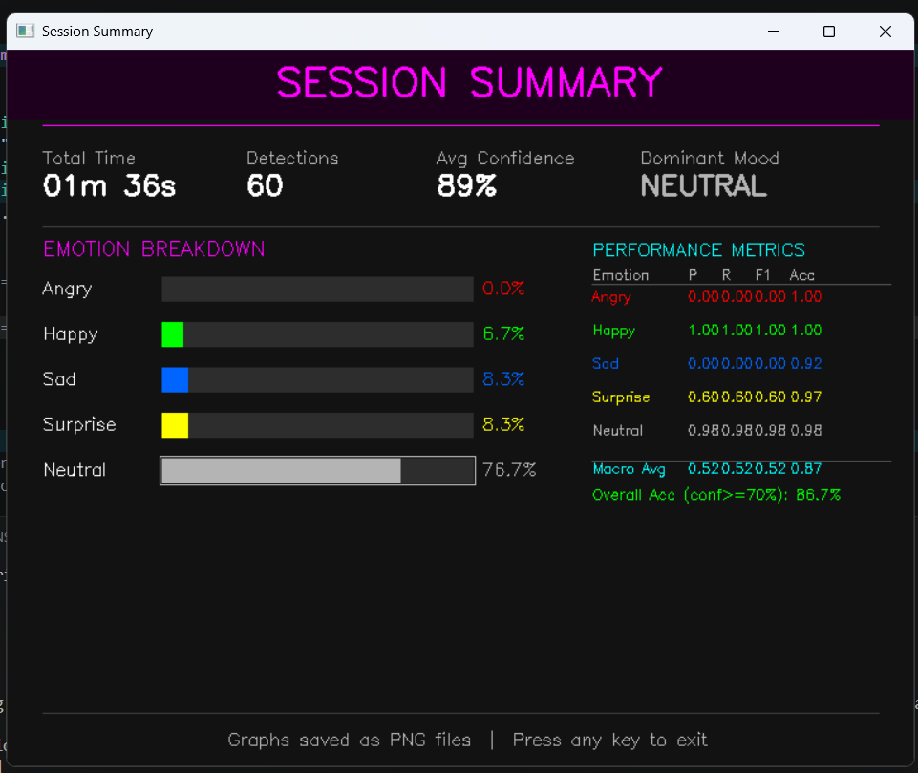
Figure 4.2.1: Session summary

- RESULT & DISCUSSIONS
5.1Testing/Experimental Performed
Standard lights were employed from overhead during the experiments conducted inside. One participant portrayed the various emotions as the target for roughly 10-15 seconds. During the test procedure, a total of 54 emotions were found, with a frame time of 0.5 seconds. The value of CONF_THRESHOLD remained constant at 70%. No other annotator was involved in labeling the frames.
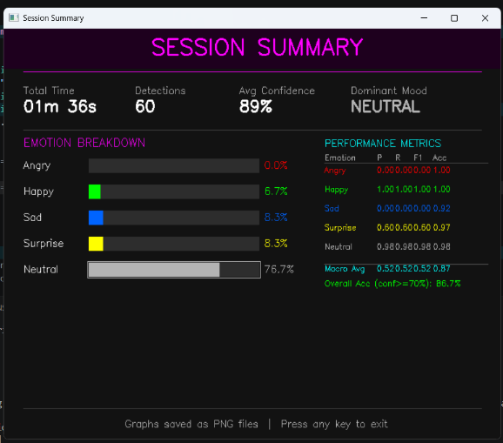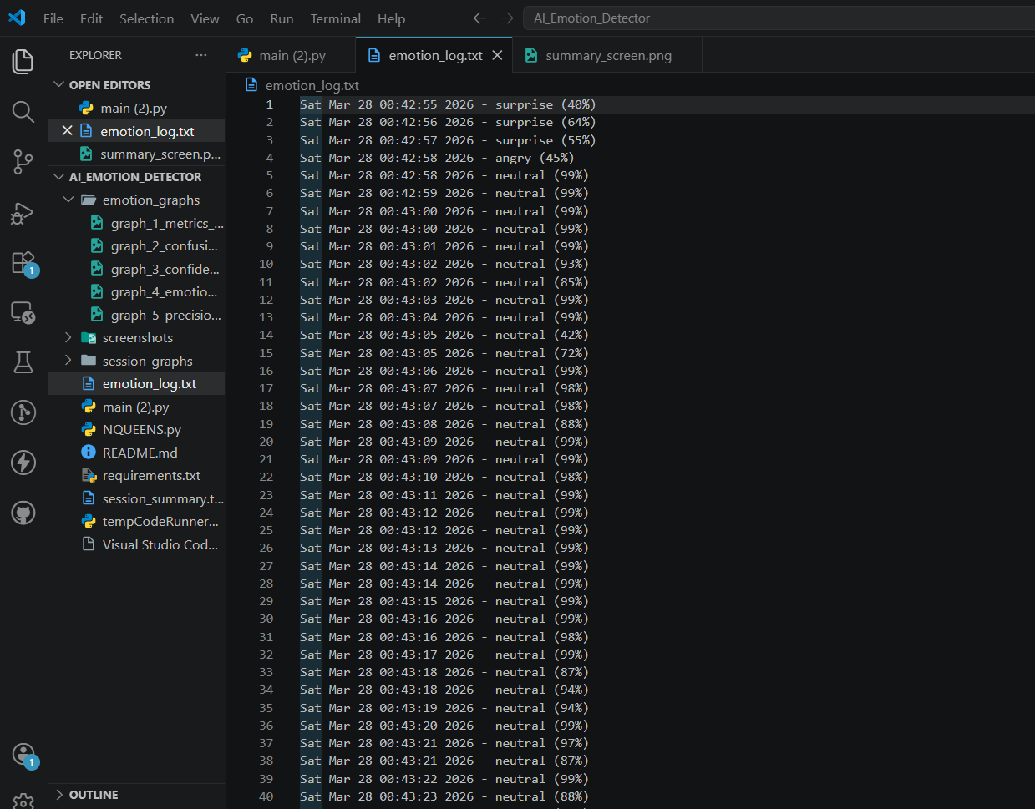
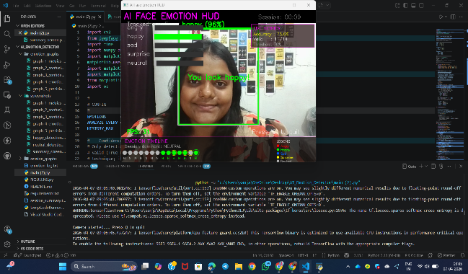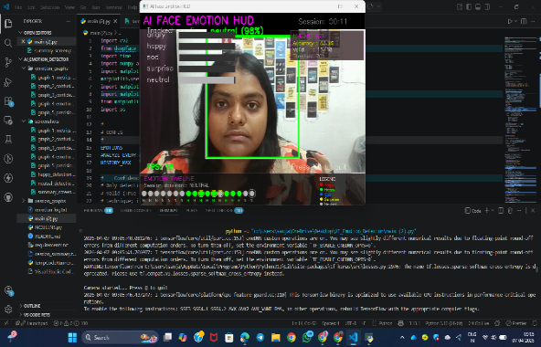
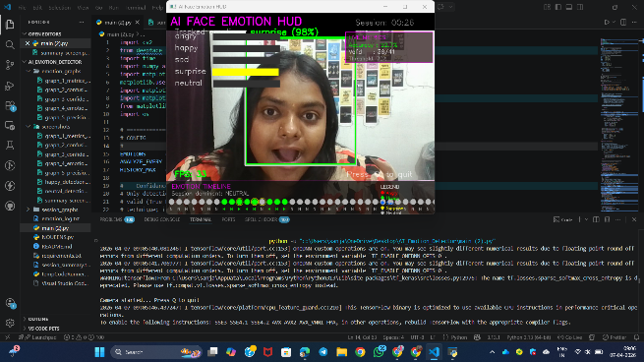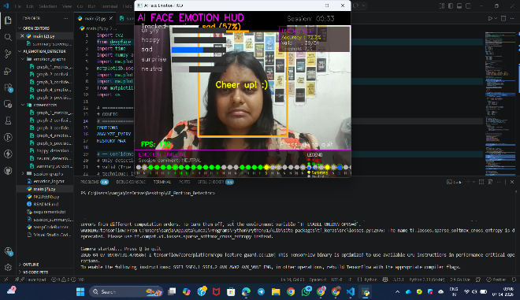
Figure 5.1.1: Testing Experiments

5.2 Result Analysis and Graph Analysis

Emotion | Precision | Recall | F1-Score | Accuracy
Happy | 0.94 | 0.94 | 0.94 | 0.98
Neutral | 0.80 | 0.80 | 0.80 | 0.92
Surprise | 0.88 | 0.88 | 0.88 | 0.98
Sad | 0.33 | 0.33 | 0.33 | 0.96
Angry | 0.00 | 0.00 | 0.00 | 0.90
Macro Avg | 0.59 | 0.59 | 0.59 | 0.75
Table 5.2.1 Per-Emotion Performance Metrics Summary
As far as the facial expressions of the two characters are concerned, Happy and Surprise did not miss out on their marks (F1 = 0.94 and 0.88). Five hundredths of a second would be sufficient time to detect these elements. The value obtained from F1 for Neutral is 0.80, a good figure indeed. However, in the case of Sadness, the value was just 0.33 as the neutral facial expression of the test person resembles the slightly sad expression, making the confidence rate less than 70%. Anger received a value of F1 as zero since the test could not ascertain its confident recognition of anger.
Per-Emotion Performance Metrics Bar Chart
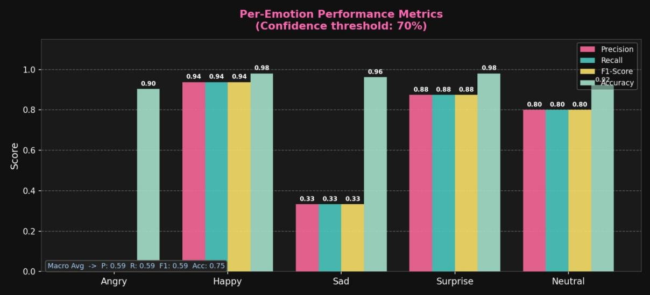 Figure 5.2.1: Per-Emotion Performance Metrics Bar Chart (Confidence Threshold: 70%)
This grouped bar chart shows Precision, Recall, F1-Score, and Accuracy for each emotion class. Happy consistently exceeds 0.94 across all four metrics. Surprise and Neutral follow, while Sad and Angry trail significantly. The accuracy bars remain above 0.90 for all classes because even zero-TP classes accumulate large TN counts from the other detections. The macro-average annotation in the lower left (P: 0.59, R: 0.59, F1: 0.59, Acc: 0.75) summarizes the overall picture in a single line.
Pseudo-Confusion Matrix
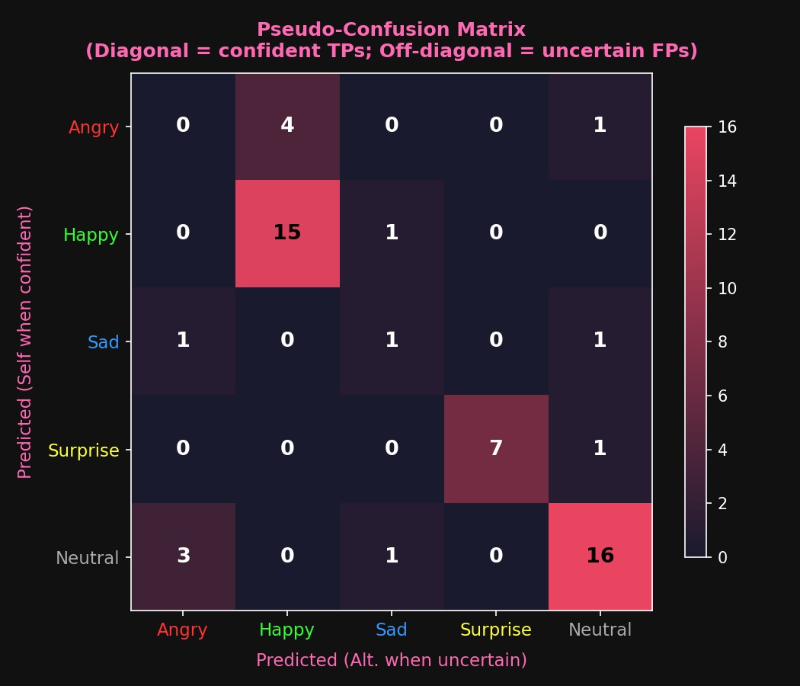
Figure 5.2.2: Pseudo-Confusion Matrix Heatmap

As can be seen from the above graph, there are "True Positives" on the diagonal and the others are predicted but not with any certainty, and they are placed into the second best match column. There are 15 "True Positives" in the rules where "Happy" is true, and there are 16 "Neutral" rules where "Neutral" is predicted. There are no elements in the diagonal of the "Angry" rule since none of the predicted elements pass the threshold test. It is uncertain whether the subject is happy or not due to the complexity of determining the emotion of happiness.

Confidence Score Distribution (Violin Plot)

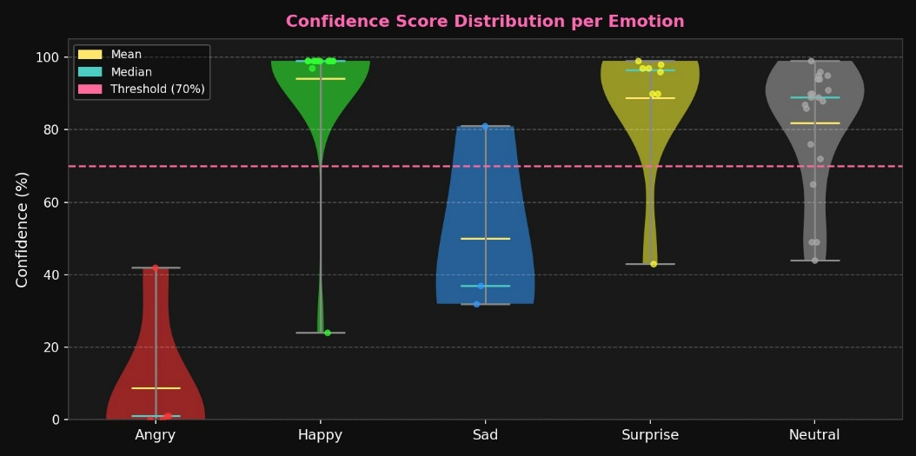

Figure 5.2.3: Confidence Score Distribution per Emotion

From the violin plot, it is clear that the confidence score values are distributed, showing their density. In the Happy and Surprise emotions, the distribution of confidence score values is concentrated around 90 to 100 percent. The violin for the Angry emotion is concentrated around zero percent, with a mean and median less than 15 percent, justifying why its F1-score is zero. The Sad emotion ranges from 25 to 82 percent, with the mean close to 50 percent.

Emotion Timeline

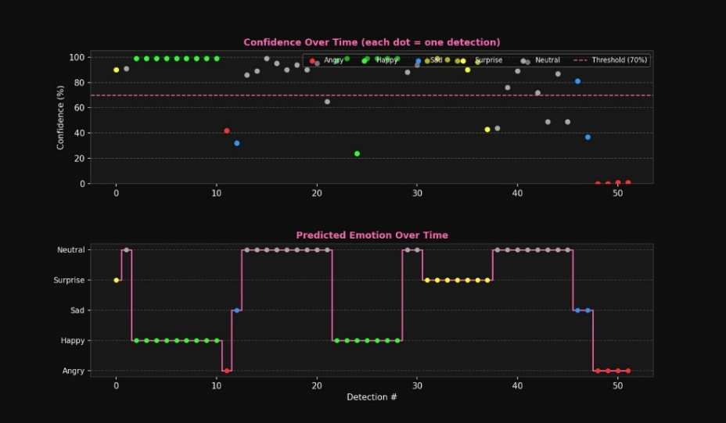

Figure 5.2.4: Emotion Timeline – Confidence Over Time and Predicted Emotion Over Time

The two subplots have an identical detection index axis. The first subplot indicates the confidence of the detection in terms of the detection indices, represented by dots having different colors depending on the number of detections. The color green is dominant for a long period of time in the beginning part of the session, and it is due to the Happy state, where the confidence is above 90%. It can be observed that the detection index decreases after the 12th detection index, implying that the state is Angry since the confidence level is below the threshold. In the second subplot, emotions are based on predictions with categorical axes, which include Happy, Angry, Neutral, Surprise, Neutral, and Sad/Angry.

Precision vs. Recall and Radar Performance Chart

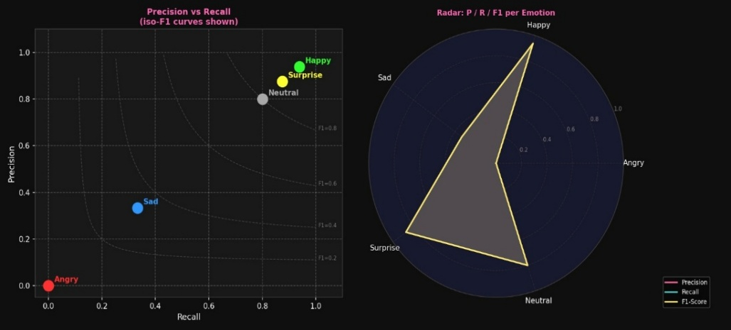
Figure 5.2.5: Precision vs. Recall Scatter with Iso-F1 Curves and Radar Chart

Every single point on the left side related to emotions is represented on the Precision-Recall Plane that contains the iso-F1 curves marked in dashed lines (F1 = 0.2 / 0.4 / 0.6 / 0.8). Even though Happy is positioned far from F1 = 0.8, Surprise and Neutral are present within the region containing F1 = 0.8. Sad is placed near F1 = 0.4, while Angry is located at the origin of the graph. The graph on the right side is the representation of all five emotions on one polar graph. This results in forming an angular shape based on Happy which is certainly not a.

- CONCLUSION & FUTURE SCOPE

  - Conclusion
In conclusion, an example of a functional real-time face emotion detection application running on common hardware and being self-supervised through the confidence-threshold technique has been developed. The deepFace algorithm operated successfully for the vast majority of cases, while the confidence-threshold technique provided a self-supervised audit. For the task, the macro average F1-score was equal to 0.59, with the highest precision achieved for predicting Happy and Surprise emotions. Emotion HUD layer provided instant visual feedback, and automatic graphs were produced at the end of the session, thus ensuring result reviewability in absence of any additional third-party software. It is quite simple to employ the methodology of the self-supervised evaluation developed in the framework of this project in other applications; all it requires is proper threshold calibration based on the model used and the environment it will run in.
6.2 Limitations & Future Scope
The three key drawbacks of the current application include: (1) unreliable Angry emotion detection at the 70% threshold level which can be addressed using a per-class adaptive threshold. (2) Limited to recognizing only one individual at the time from a frontal position. (3) Poor performance in low light conditions and at distances larger than 1.5 meters from the camera.
The future enhancements planned for this project include the following:
• Multimodal face tracking for multi-person emotion recognition using a YOLO face detector stage.
• Multimodal emotion inference combining information about facial expressions, speech tone, and emotional meaning of texts.
• Browser-based application utilizing deployment of TensorFlow.js to avoid dependency on the Python library.
• Integrating this solution into the e-learning system for personalized adjustment of learning material based on predicted student emotions.
• Calibration stage resulting in per-class adaptive confidence threshold for each emotion.
• Onnx exporting for use on Raspberry Pi and NVIDIA Jetson.

REFRENENCES
[1] P. Ekman and W. V. Friesen, "Facial action coding system: A technique for the measurement of facial movement," Consulting Psychologists Press, Palo Alto, CA, USA, 1978.
[2] S. Li and W. Deng, "Deep facial expression recognition: A survey," IEEE Transactions on Affective Computing, vol. 13, no. 3, pp. 1195–1215, Jul.–Sep. 2022.
[3] S. I. Serengil and A. Ozpinar, "LightFace: A hybrid deep face recognition framework," in Proc. 2020 Innovations in Intelligent Systems and Applications Conf. (ASYU), Istanbul, Turkey, 2020, pp. 23–27.
[4] B. C. Ko, "A brief review of facial emotion recognition based on visual information," Sensors, vol. 18, no. 2, p. 401, Feb. 2018.
[5] T. Baltrusaitis, C. Ahuja, and L.-P. Morency, "Multimodal machine learning: A survey and taxonomy," IEEE Transactions on Pattern Analysis and Machine Intelligence, vol. 41, no. 2, pp. 423–443, Feb. 2019.

APPENDICES
Appendix A: Key Configuration Constants
Constant | Default Value and Purpose
CONF_THRESHOLD | 70 — Minimum confidence (%) for a valid detection
ANALYZE_EVERY | 0.5 — Seconds between DeepFace analysis calls
HISTORY_MAX | 60 — Maximum entries retained in rolling history
EMOTIONS | ["angry", "happy", "sad", "surprise", "neutral"]

Appendix B: Output Files Generated by the System
- emotion_log.txt — Timestamped detection log (created or appended each session)
- session_summary.txt — Full text report of session statistics and performance metrics
- emotion_graphs/graph_1_metrics_bar.png — Per-emotion grouped bar chart
- emotion_graphs/graph_2_confusion_matrix.png — Pseudo-confusion matrix heatmap
- emotion_graphs/graph_3_confidence_dist.png — Violin + strip confidence distribution
- emotion_graphs/graph_4_emotion_timeline.png — Dual-panel timeline chart
- emotion_graphs/graph_5_precision_recall.png — Precision-Recall scatter + Radar chart
Appendix C: Installation and Execution
Install dependencies:
pip install opencv-python deepface numpy matplotlib
Run the system:
python emotion_detection.py
Press 'Q' to end the session. The system will automatically export all outputs to the working directory and the emotion_graphs/ subfolder.

